Project Report Template

CHARTING THE COURSE OF INNOVATION: A STARTUP ANALYSIS.

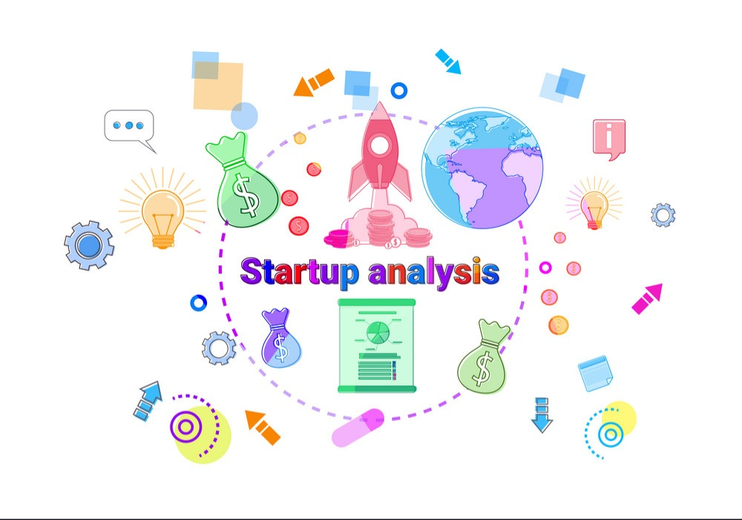

1. **Introduction** 
   1. Overview

Starting a new company can be an exciting and rewarding experience, but it also requires careful planning and analysis to ensure that the business is viable and successful. There are several key areas that you should focus on when conducting a startup company analysis. Conducting a thorough analysis of these areas can help you identify potential challenges and opportunities, and develop strategies to address them. It is also important to regularly review and update your analysis as the business progresses, in order to adapt to changing market conditions.

* 1. **Purpose**

The purpose of a startup is multi-faceted, depending on the individual or team behind the venture. Generally, though, the purpose of a startup is to create something new and innovative. A startup is often the first step in launching a business venture, and is the beginning of an entrepreneurial journey.

1. **Project definition and design thinking** 
   1. Empathy Map
   2. 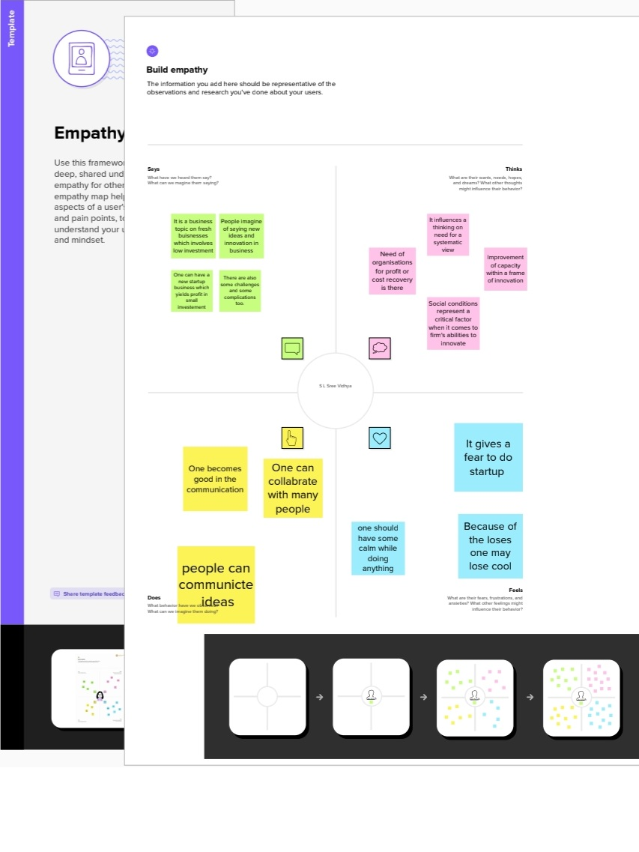Ideation and brainstorming Map

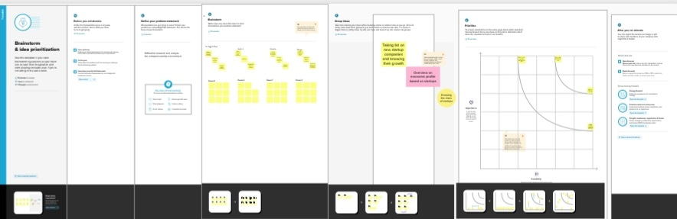

1. **Result**

*Dashboard*

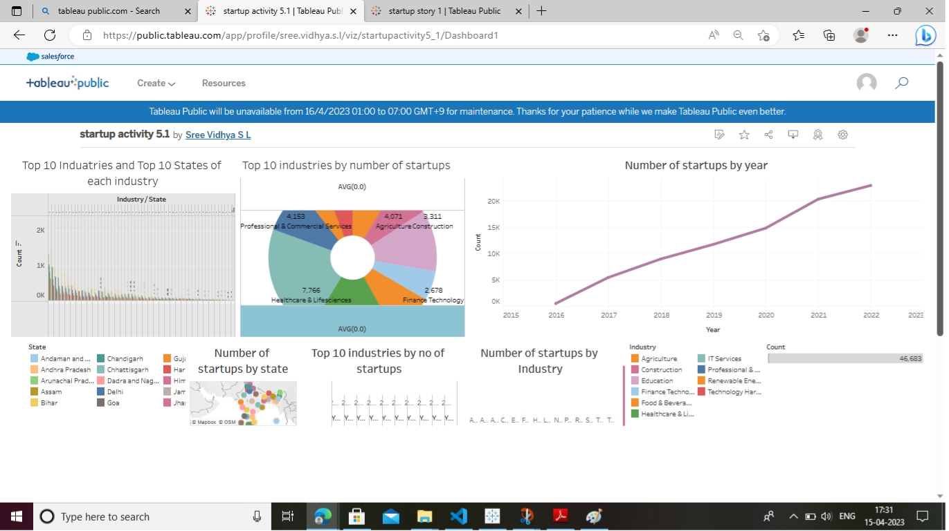

*Story*

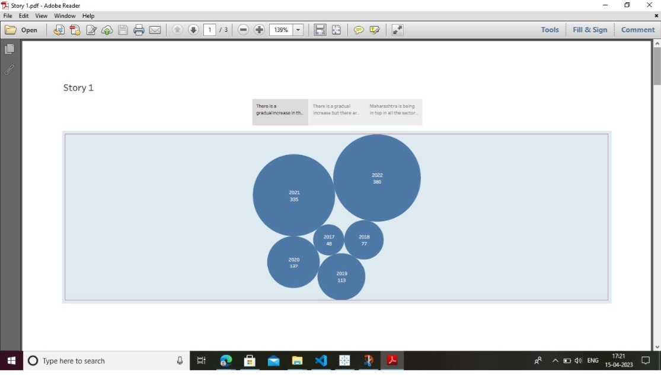

1. **Advantages &**

**disadvantages**

*Advantages*

* They are innovative and keep improving their business models, processes, and portfolio.
* Startups offer their services in a more efficient, cost-effective and competitive manner.
* Startup employees form a close-knit community that shares passion, beliefs, and values.
* Startup employees form a close-knit community that shares passion, beliefs, and values.
* Startups are very flexible and are more likely to work at the hours, the place and in the manner that suits you.

*Disadvantages*

* Most startups fail within their first year of operations, so the risk of failure is high.
* It takes blood, sweat, and tears to build a company, and long working hours are the norm for startups. The rewards might be low since it takes time to generate revenue and make profits.
* Many customers prefer a business that they have worked with over a new startup. Without a customer base, understanding market needs also becomes a real struggle.
* Startups are flat organizations that lack defined business processes and operational procedures.
* Low compensation, many responsibilities and long working hours are more or less expected.

**5 Applications**

The startups provides a framework to create the value proposition, team strategy market strategy and financial strategy to building a startup easier and faster.

**6 Conclusion**

Startups are small companies but they play a vital role in the economic process. They create more jobs which insinuates more employment and more employment means and improved economy.

**7 Future Scope**

The number of startup rose from 471 in 2016 and 72993 in 2022 and created more than 7,00,000 job by March 2022. India is the third largest in the startup ecosystem after the US and China.

**8 Appendix**

1. Source code

file:///C:/Users/ELCOT/Desktop/startup%20analysis%20integration/Charting%20the%20Course%20of%20Innovation_%20A%20Startup%20Analysis/index.html